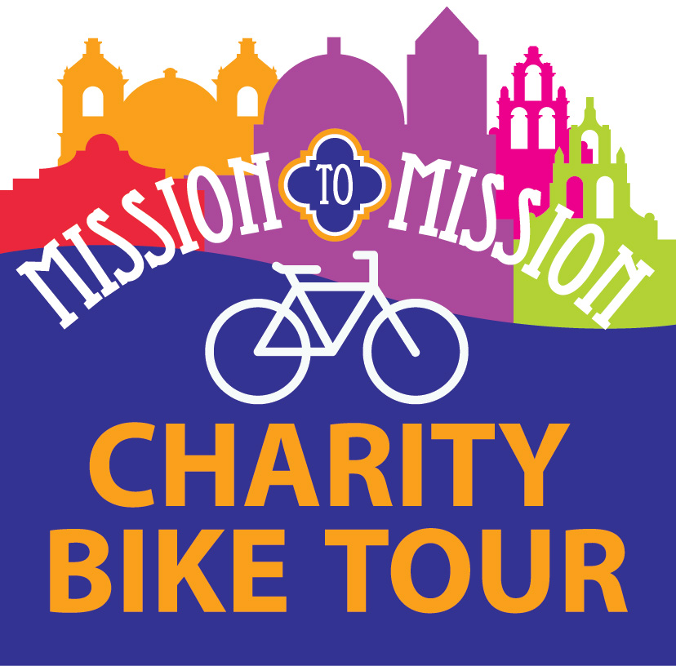  www.M2Msa.org |  | Mission to Mission Charity Bike Tour  Sponsorship Agreement & Invoice  Event Date: Saturday, Dec. 4, 2021  In return for good faith effort to provide the enumerated sponsorship marketing and perquisites below, I agree to contribute a sponsorship in the amount of:  ☐ $2,500 TITLE SPONSORSHIP - Exclusive merchant - Logo on ride shirt as title sponsor - Logo featured on M2M website, Facebook and Instagram pages - Logo on promotional materials - Eight rider registrations  ☐ $1,000 SAN JUAN SPONSORSHIP - Logo on ride shirt - Logo featured on M2M website, Facebook and Instagram pages - Listed on promotional materials - Four rider registrations  ☐ $500 SAN JOSE SPONSORSHIP - Logo on ride shirt - Logo featured on M2M website, Facebook and Instagram pages - Listed on promotional materials - Two rider registrations  ☐ $250 ESPADA SPONSORSHIP - Name on ride shirt - Listed on M2M website, Facebook and Instagram pages - Listed on promotional materials - Two ride shirts  ☐ $100 CONCEPCION SPONSORSHIP - Name on ride shirt - Listed on M2M website, Facebook and Instagram pages - One ride shirt  ☐ IN-KIND CONTRIBUTIONS will be recognized at a sponsorship level matching the retail value of the contribution. Value $_______________  I authorize MTR Charities, Inc.to publish and display all provided artwork / logos in the manner specified in the selected sponsorship. Please make check payable to MTR Charities, Inc. and mail to P.O. Box 831451, San Antonio, TX 78282.  Authorized signature: ______________________________________Date: ______________________  Amount enclosed: ____________________________________ Check #________________________  In-kind contribution: __________________________________________________________________  ___________________________________________________________________________________  Company / Organization: ______________________________________________________________  Address: ___________________________________________________________________________  ___________________________________________________________________________________  Contact name: _______________________________________ Phone:_________________________
San Antonio
Mission Trail Rotary Club
P.O. Box 831451
San Antonio, Texas
78282-1451
MissionTrailRotary.org
MTRCharities.org
For additional information, contact ride director:
Mariella Ozuna
ridedirector@M2Msa.org
(210) 643-9315
MTR Charities, Inc. is a 501(c)3 tax-exempt organization organized by the San Antonio Mission Trail Rotary Club. MTR Charities, Inc. conducts fundraisers and distributes the proceeds for charitable and educational purposes, and is qualified to receive tax-exempt donations.

